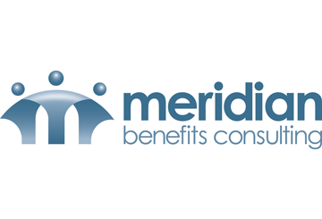
The main difference between a traditional 401(k) and a Roth 401(k) is when the money is taxed. With a traditional 401(k) plan, an employee’s contributions are made on a pre-tax basis, and the employee is taxed upon withdrawal from the plan during retirement.
Who should invest in a Roth 401(k), and who should go with the traditional 401(k)? What are some strategies for determining this?
Courtesy of Meridian Benefits Consulting
Conversely, an employee’s Roth 401(k) contributions are made after taxes have been taken out, and withdrawals in retirement are tax-free. An employee may want to consider what tax bracket he or she is in now and compare it to the tax bracket he or she expects to be in during retirement.
A Roth 401(k) may be the best choice if an employee is just beginning his or her career and anticipates higher earnings later in life. Since the Roth 401(k) involves paying taxes now rather than later, this individual would be getting more money at retirement because there are fewer taxes taken out now—due to having a lower income—than there would be later on when he or she is earning more money.
Roth 401(k) plans might also be a good choice for higher-paid employees who are not eligible for Roth IRAs and other similar plans. The tax-free withdrawals would help highly paid employees manage their taxes in retirement.
For workers who are closer to retirement, Roth 401(k)s may not be as appealing. Since an individual will likely be in a higher tax bracket when contributing to the account than when he or she is retired and decides to withdraw from the account, the individual may prefer to pay taxes when he or she retires and is in a lower tax bracket.

